Design Specifications – Java Case Study
Pet Peers

Release Date: 19-Apr-2021
Revision: 3.0

Copyright Notice
The information contained in this document is the property of HCL Technologies Limited. Except as specifically authorized in writing by HCL Technologies Limited, the holder of this document shall: (1) keep all information contained herein confidential and shall protect same in whole or in part from disclosure and dissemination to all third parties and, (2) use same for operating and maintenance purposes only

 | Name | Role / Function | Date | Signature
Reviewed By
Approved By

Revision History
Revision No. | Date | Prepared By | Summary of changes
0.1 | 19/Oct/16 | Ram Kaila | Initial Draft
1.0 | 31/Oct/16 | Java Capability Team | Internal review comments
2.0 | 31/Oct/16 | Shailesh Chauhan | Added section 11
3.0 | 19/Apr/21 | Anbarasu Venkatachalam | Evaluation Tool synchronisation

Glossary
Abbreviation / Terminology | Description / Definition

Table of Contents
1. Introduction 5
1.1 Introduction 5
1.2 Scope 5
1.3 Intended Audience 5
1.4 Assumptions 5
3.1 Reference Documents 6
4. Application Overview 7
5. System Components 8
6. Technology Stack 9
7. Application Screens 10
7.1 User Registration 10
7.2 Successful Registration 11
7.3 Login 11
7.4 Pet List (Home) Page 12
7.5 Pet Form (Add a Pet) Page 12
7.6 My Pets Page 13
8. UI Components 14
8.1 Controller 14
8.2 Form Field Validators 15
8.3 Model Class 16
9. Business Service Components 17
9.1 General request processing 17
10. Class Diagram 18
10.1 Classes Diagram 18
11. Database Specification 19
12. Implementation Scenarios 20
13. Instructions 21

Introduction

Introduction
This document provides the design specifications for the Pet Peers application to be developed by the Java trainees as part of their training curriculum. The trainees are required to understand the design specifications and implement the functionality as required. Trainees would also receive a partially implemented skeleton project for this application. The trainees only need to complete the implementation by adding the missing code in the application components. The application uses the technologies covered in the training curriculum only.

Scope
This document covers the detailed design input for Java trainees to implement the Pet Peers application functionalities.
The document addresses the following areas,
- System Inputs and Outputs
- Technology stack
- System Components
- Behavioral Description
- Data model

Intended Audience
Java Trainees

Assumptions
- The necessary libraries for this project are declared in the Maven pom.xml file. It is assumed that either the internet is open for the trainees so that eclipse can download the required jars & libraries or a maven local repository is created & configures in Eclipse.
- The screen shots are intended for information purpose only. The look and feel of the screens are purely at the discretion of the developer.
- There is no restriction on the database engine. The trainee can choose any RDBM for storing/retrieving the application data, but he must follow the table structure provided in this document. The reference implementation uses MySQL 5.7.15 Community Edition

Reference Documents
Sr. No | Document ID / File Name | Document Description
Table 1: Reference Documents

Application Overview

Pet Peers is a web based application, which provide features such as storing & retrieving pet information, listing available pets and view details for a specific pet. It also allows a user to login/register, buy pets and view the pets owned by him.
The following are the Use Cases for the Pet Peers application.
- User Registration – New users can register themselves by entering a unique user name and password.
- User Login – Users should be able to login into the application by entering a correct user name and password
- View List of all Pets – This functionality lists all pets and also indicates whether a Pet is ‘Sold Out’ or available for purchase. If available, it provides a link to buy that Pet.
- Add a Pet – A user can enter a new Pet to the list.
- Buy a Pet – If a User likes an available Pet, she / he can buy the same by clicking on the ‘Buy’ button.
- List of owned Pets – A logged in user can view the list of Pets owned by him/her by clicking on ‘My Pets’ button.
- User Logout – A user can logout of the application by clicking on ‘Logout’ button. Hershel can access the application functional only after logging in again.

The trainee will be provided with a partially implemented eclipse web application project template and the design specifications (this document) to develop the application. The trainee is expected to create the necessary objects and components in the given project template.

The template project structure follows the standard Maven web application structure.

System Components

The PetPeers application has been divided into 3 layers.

- Web UI
- Business Components
- Data Access Components

The tools/technologies for developing these components are as follows,

S. No. | Component | Technology/Tools | Notes
1. | Web UI | View pages (implemented by JSP using HTML, CSS, and JS etc.) | Empty JSP pages are included in eclipse template project
2. | Web UI | Spring MVC Components – Controller, Model classes for data handling and Validators for user input | Controller to handle the request, invoke server components and send response back to user. Template classes and configuration are included
3. | Business Service Components | Business Service components to be invoked by Controller(s) implemented as Spring Beans in Java | Classes with empty implementations included.
4. | Data Access Components | DAO components for data persistence and retrieval implemented using Hibernate ORM framework | Partial Configuration and empty classes included in eclipse project template

Technology Stack
The list of technologies and tools to be used in this application development is given below,

S. No. | Technology/Tools | Notes
1. | JSP (HTML, CSS, JS etc.) | Java Server Pages for UI
2 | Servlet Filter | To intercept all user requests and enforce user authentication
3. | Spring MVC | MVC framework for web application development. Provides extensive infrastructure for rapid development of functional components.
4. | Spring | Business services are implemented as lightweight Spring bean components
5 | Hibernate ORM | For data access and persistence
6 | Log4j 2 | For logging and debugging

The reference implementation of Pet peers application has used following tools / frameworks:
- Eclipse IDE
- JDK 8
- Tomcat 9
- MySQL 8 Community Edition

Application Screens

This section describes the user interface of the application.

User Registration

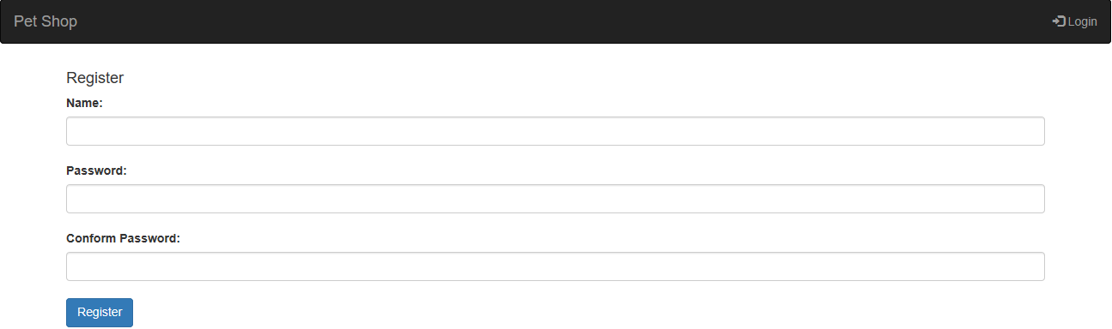

Sr. No | File Name | Folder | UI Controls
1. | registrationPage.jsp | ./webapp/WEB-INF/jsp | Fields for new user registration, Links to “Home” and ‘Login’

- All fields are mandatory.
- If a User Name is already taken, user shall be prompted to choose a different user name.
- ‘Password’ and ‘Confirm Password’ values should be exactly same.
- Once successfully registered, user will be presented login page with success message

Successful Registration
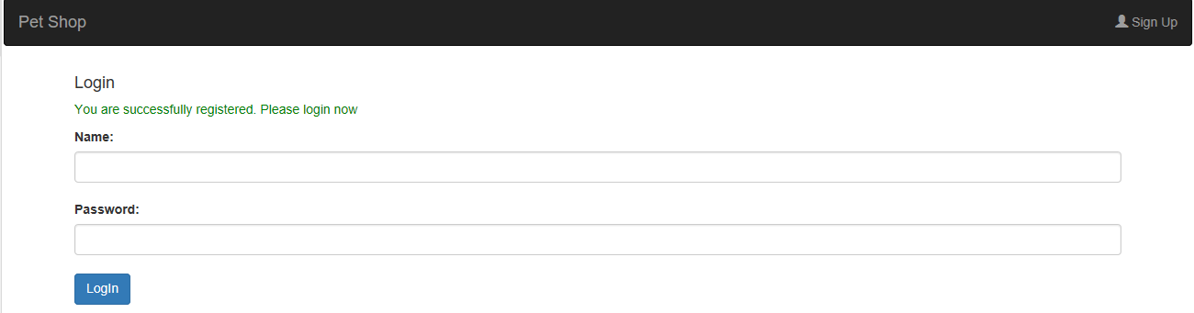

Sr. No | File Name | Folder | UI Controls
1. | loginPage.jsp | /webapp/WEB-INF/jsp | Link to ‘Login’

Login

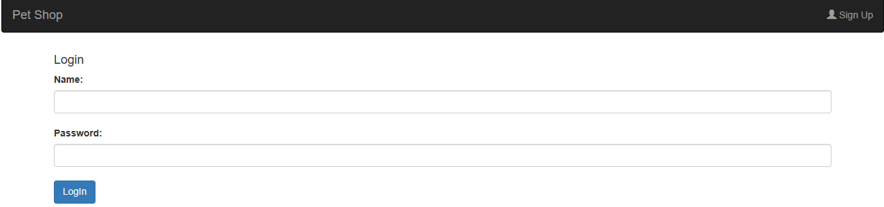

Sr. No | File Name | Folder | UI Controls
1. | loginPage.jsp | ./webapp/WEB-INF/jsp | Link to ‘Sign In’ and Reset

- All fields are mandatory
- Both user name and password shall match values in database.
- On successful login, User will be directed to the home page.

Pet List (Home) Page
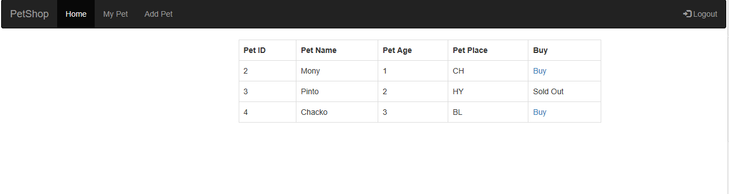

Sr. No | File Name | Folder | UI Controls
1. | homePage.jsp | ./webapp/WEB-INF/jsp | Table for list of Pets. Links to “Home”, “Add Pet”, ‘My Pets’ and “Logout”

- The home page should display the list of pets available in the database table.
- If a Pet is purchased by clicking the ‘Buy’ button, currently logged-in user is mapped as owner of that Pet and the same is marked as ‘Sold Out’.
- Buy action on a Sold pet is disabled

Pet Form (Add a Pet) Page

This page is used for adding a new Pet.

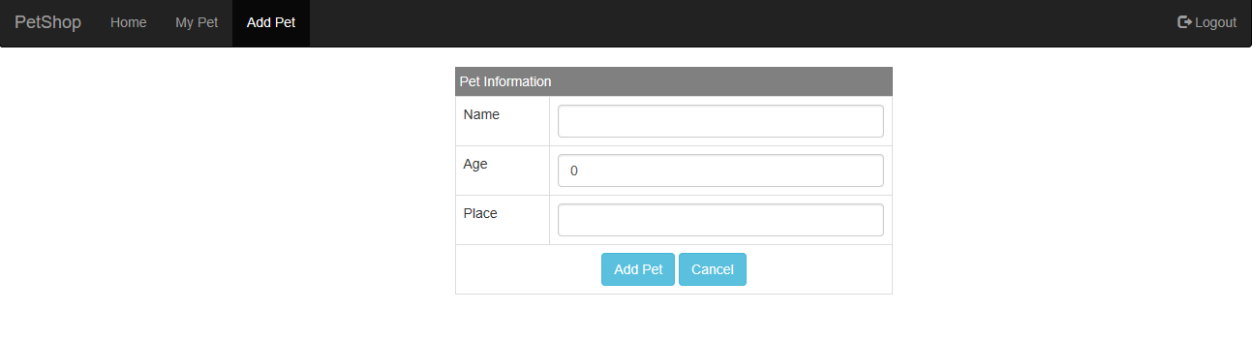

Sr. No | File Name | Folder | UI Controls
1. | addPetPage.jsp | ./webapp/WEB-INF/jsp | Text box for each data field. Add Pet and Cancel buttons. Home, My Pets & Logout links.

- The data input form page of the Pet Peers application should have fields to collection required information.
- The ‘Add Pet button should submit the given field data to database.
- The ‘Cancel’ button is used to reset the form to bring-back to original state.
- Clicking on ‘Home’ link should take to home page.
- Clicking on ‘My Pets link should take to My Pets page.
- Clicking on ‘Logout’ link should invalidate session and take user to login page.

My Pets Page

This page is used for listing all the pets owned by the currently logged in user.

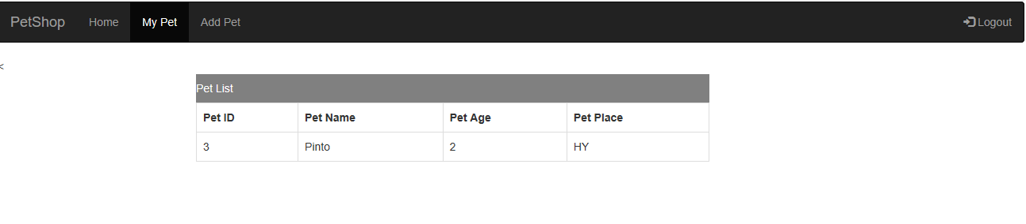

Sr. No | File Name | Folder | UI Controls
1. | myPetsPage.jsp | ./webapp/WEB-INF/jsp | Home, Add Pet & Logout links.

- Clicking on ‘Home’ link should take to home page.
- Clicking on ‘Add Pet link should take to Add Pet page.
- Clicking on ‘Logout’ link should invalidate session and take user to login page.

UI Components

Beside the JSP screens described above, UI components include the following:

Controller
This component receives all user requests, invokes appropriate service in the business services layer and returns the appropriate view to user. The description of the Controller class and its methods and request mappings is given below.

File Name | MainController
Type | Spring MVC Controller
Package | com.hcl.cs.controller

User Stories | Request Mapping URI | Controller Method | Service Class & Method | Jsp view name / redirect to URI
User Registration | /saveUser | saveUser(@ModelAttribute("user") User user) | userService.saveUser(User) | Success - loginPage.jsp,  Error – registrationPage.jsp
User Login | /authenticateUser | authenticateUser(HttpServletRequest request, @ModelAttribute("user") User user) | userService.authenticateUser | Success – homepage.jsp  Error – loginPage.jsp
Home | /home | home() | petService.getAllPets() | homePage.jsp
User Logout | /logout | logout(HttpServletRequest request) | - | loginPage.jsp
My Pets | /myPets | myPets(HttpServletRequest request) | userService.getMyPets(int) | myPetsPage.jsp
Save Pet | /savePet | savePet(@ModelAttribute("pet") Pet pet) | petService.savePet(Pet) | homePage.jsp
Buy a Pet | /buyPet | buyPet(HttpServletRequest request) | userService.buyPet(int,int) | /myPets

Form Field Validators
User input received from HTML form fields is validated using Spring MVC validators. The errors are displayed appropriately in the UI screens.

The error messages need to be internationalized and all message texts need to be specified in the properties files. Depending on the specific locale of the user appropriate text should be displayed to the user on the application screen.

The table below lists the validators, their methods and user messages (in default, locale).

Class | Package | Method | Description | Property file for default locale
UserValidator | com.hcl.cs.validator | validate | To validate user registration form fields  - All fields are mandatory – Mandatory Field  - Make sure user name is unique - User Name already in use. Please select a different User Name  - Password and Confirm Password values should match - Passwords do not match | messages.  properties
LoginValidator | com.hcl.cs.validator | validate | To validate login form fields  - All fields are mandatory - Mandatory Field  - If user name and password values do not match, error message is displayed - Either User Name or Password or both are invalid | messages.  properties
PetValidator | com.hcl.cs.validator | validate | To validate entry of a new Pet  - All Fields are mandatory - Mandatory Field  - Age filed should be numeric between 0 and 99. – Age should be 0 and 99 years | messages.  properties

Model Class
The model class is a representation of data in database tables like Pet and User. These objects are used to carry data across layers like presentation, business services, etc. Pet Peers application has following model objects

Class Name | Pet.java | User.Java
Type | POJO | POJO
Package | com.hcl.cs.model | com.hcl.cs.model
Fields | petId (Long), petName (String), petAge (Integer), petPlace (String), user (User) | userId (Long), userName (String), userPassword (String), confirmPassword (String), pets (Set)
Methods | Getters and Setters | Getters and Setters

Business Service Components

The components in this layer implement the business functionality and are implemented as Spring beans in the application. The key services and their description is given below.

General request processing
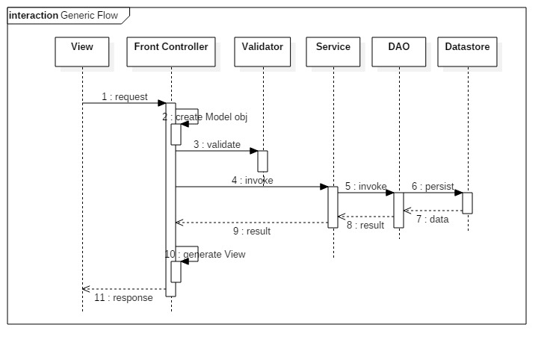

Class Diagram

Classes Diagram
The following diagram captures the design of controller class, service interface, class and dao interface and class.
Please do follow same naming convention of the package, class and methods name and signature as in below class diagram

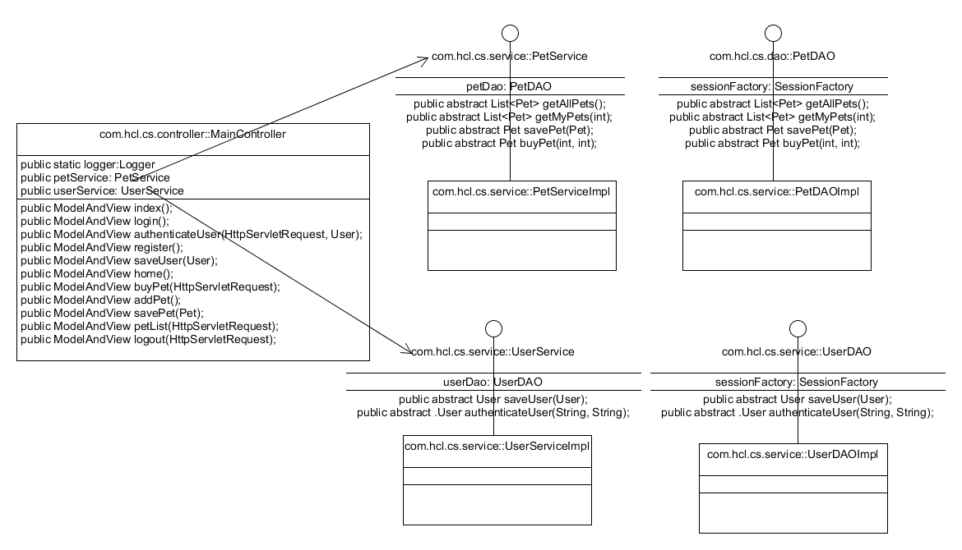

Database Specification
This section specifies the database and tables to be used in the Pet Peers application.

Database Name | PETSDB
Tables | PETS,  PET_USER

- SQL script.
DROP TABLE IF EXISTS PET;
DROP TABLE IF EXISTS USER;

CREATE TABLE USER (
PETID INT(5) NOT NULL AUTO_INCREMENT,
USERNAME VARCHAR(55) NOT NULL UNIQUE,
USERPASSWORD VARCHAR(55) NOT NULL,
PRIMARY KEY (USERID)
);

CREATE TABLE PET (
PETID INT(5) NOT NULL AUTO_INCREMENT,
PETNAME VARCHAR(55) NOT NULL,
PETAGE INT(2),
PETPLACE VARCHAR(55),
PETOWNERID INT(5) NULL,
FOREIGN KEY (PETOWNERID)
REFERENCES PETUSER(id)
ON DELETE CASCADE,
PRIMARY KEY (PETID)
);

INSERT INTO PETS VALUES(0,'Jicko',4,'CH', NULL);
INSERT INTO PETS VALUES(0,'Lola',2,'DL', NULL);
INSERT INTO PETS VALUES(0,'Chacko',3,'BL', NULL);

Implementation Scenarios
The trainees are expected to implement this case study in 3 parts.
- Case Study 1 - The first step is to implement the core Java classes used in the Pet Peers application and save the information represented by the model classes (Pet, User) in the database. This step should be implemented using core Java features only (using JDBC to connect to the database). JUnit should be used to unit test the code. This case study is to be developed after completion of the “PF & OOP Using Java” and “SQL & JDBC” modules.
Technologies used : Java, JDBC, JUnit
- Case Study 2 – The second step would involve adding a front-end user interface using Java Servlets and JSPs to the application developed in the previous step.
Technologies used : Java, JDBC, Servlets, JSPs, CSS
- Case Study 3 – The third step involves developing the complete application as described in the previous sections of this document using Spring and Hibernate framework.
Technologies used : Java, JSPs, Spring, Hibernate

Instructions
- Import the template project into your local eclipse workspace using import wizard.
- Configure local maven repository, if necessary
- Configure JRE and Tomcat server in eclipse
- Install database of your choice and create the tables as specified. The given script was developed for MySQL. Depending on your choice of the database, you may have to tweak the script to work for your database engine.
- Configure the datasource in Spring configuration file (spring-core-config.xml in folder src/main/webapp/WEB-INF) or PetConfig.java under "dao" package.
- Develop and test the JSPs, Controller, Service classes and DAOs.
- Unit test all your DAO and Service implementation classes using JUnit framework.
- Make sure you provide comments at appropriate places in your code.
- Also insert appropriate logging and debugging code throughout your code (at right levels like info, debug, error, etc.) so that it is easy to maintain your code.
- Finally, after completing your implementation, you can check and compare your code with the reference implementation.

